Business Dashboard Project (Sales Dataset)

Data Analytics - MINI PROJECT REPORT

Submitted by

VISHVAM PARIHAR (24MCI10010)

in partial fulfillment for the award of the degree of
MASTER OF COMPUTER APPLICATIONS

IN

COMPUTER APPLICATIONS



Chandigarh University, India.

April, 2026



CERTIFICATE OF ACCEPTANCE

Certified that this project report “Business Dashboard Project (Sales Dataset)“ is the bonafide work of “VISHVAM PARIHAR” who carried out the project work under my/our supervision.
This project work is hereby accepted by the Department of Computer Applications, University Institute of Computing, Chandigarh University, India, in partial fulfillment of the requirements for the award of Degree in Master of Computer Application.

SIGNATURE
Dr. Kawaljit Kaur
(Associate Professor)
SUPERVISOR

ACKNOWLEDGEMENT

We would like to express my heartfelt gratitude to all those who assisted us in preparing and completing our Major Project report titled “Business Dashboard Project (Sales Dataset)”.I extend my sincere appreciation and thanks to Dr. Kawaljit Kaur for inspiring, cooperating, and encouraging us to pursue my work.
With his valuable suggestions and guidance, I was able to complete my work in a short time frame at this institution.
I also convey our respect and gratitude to Dr. Amandeep Kaur, (HOD) University Institute of Computing, and Chandigarh University, as well as all the faculty members, for their valuable suggestions and guidance towards completing the report.
Furthermore, I’m grateful to all our academic mentors who provided direct or indirect assistance in successfully completing our major project report.
Last but not least, I’m immensely grateful to our parents, who served as a constant source of encouragement and inspiration throughout the completion of this work at Chandigarh University, Mohali.

Vishvam Parihar (24MCI10010)

Table of Contents

- Introduction
- Objectives
- About Tableau
- Dataset Description
- Methodology
- Dashboard & Visualizations
- Types of Filters used
- Results & Insights
- Conclusion
- Future Scope

Abstract

In the modern era of data-driven decision-making, analyzing large volumes of data efficiently has become a critical requirement for organizations. This project focuses on leveraging the capabilities of Tableau to perform in-depth data analysis and present the results through an interactive dashboard.
The primary objective of this project is to convert raw business data into meaningful and visually appealing insights that can support strategic decision-making. The dashboard, titled “Business Summary”, integrates multiple visual components such as bar charts, stacked bar charts, pie charts, and tabular heatmaps to represent different aspects of the dataset.
The analysis includes key performance indicators (KPIs) such as total sales amount, total number of boxes shipped, and total number of records. Additionally, it explores sales performance across various countries, evaluates the contribution of top-performing salespersons, analyzes shipment distribution, and examines product share across different regions.
This project demonstrates how data visualization tools can simplify complex datasets, enhance understanding, and enable stakeholders to make informed business decisions effectively.

  - Introduction
The purpose of this project is to design and develop an interactive business dashboard using Tableau that provides a comprehensive analysis of sales data. In real-world scenarios, businesses deal with large datasets that are difficult to interpret in raw form. Therefore, visualization plays a crucial role in transforming this data into an understandable format.
In this project, a dashboard has been created to analyze business operations across multiple dimensions such as geography (countries), human resources (salespersons), logistics (shipment count), and product distribution.
The dashboard consists of several components:
- A Business Summary section displaying key performance indicators
- A Sales by Country chart for geographic comparison
- A Top 10 Salespersons visualization for performance analysis
- A Shipment Distribution pie chart for logistics insights
- A Product Share heatmap to understand product popularity across countries
Through this dashboard, users can quickly gain insights into business performance, identify trends, and make comparisons across different dimensions. The project highlights how Tableau enables users to build powerful dashboards without requiring complex programming skills.

  - Objectives
The objectives of this project define the purpose and goals behind creating the Tableau dashboard.
The primary objective is to analyze business sales data using Tableau and convert raw data into meaningful visual insights.
- Explanation:
- The project aims to simplify complex data by representing it through charts and dashboards instead of tables.
- It focuses on understanding sales performance across different countries, helping identify which regions are performing well.
- Another key objective is to analyze the performance of salespersons, which helps in recognizing top contributors.
- It also aims to study shipment distribution, giving insights into logistics and delivery efficiency.
- Additionally, the project analyzes product-wise performance across countries, helping in understanding market demand.
In simple words:
The objective is to turn raw business data into useful information that helps in better decision-making.

  - About Tableau
Tableau is a widely used Business Intelligence (BI) tool that helps in transforming raw data into meaningful and interactive visualizations.
- Detailed Features:
- Drag-and-Drop Interface: Allows users to create visualizations easily without coding
- Real-Time Data Analysis: Supports live data connections
- Interactive Dashboards: Users can filter and explore data dynamically
- Data Blending: Combines data from multiple sources
- Scalability: Handles large datasets efficiently
- Importance of Tableau in this Project:
- Simplifies complex business data
- Provides quick insights through visualization
- Enhances understanding through graphical representation
- Enables better communication of results
- Applications:
- Sales and marketing analysis
- Financial forecasting
- Supply chain management
- Healthcare analytics
- Academic research

  - Dataset Description
The dataset used in this project represents business sales data across multiple countries and includes both numerical and categorical variables.
🔹 Dataset Structure:
- Total Records: 1,094
- Total Sales Amount: $6,183,625
- Total Boxes Shipped: 177,007
🔹 Attributes Included:
- Country: Represents different geographical regions such as Australia, Canada, India, New Zealand, UK, and USA
- Sales Amount: Indicates revenue generated
- Boxes Shipped: Represents shipment volume
- Sales Person: Identifies individuals responsible for sales
- Product Categories: Different types of products sold
🔹 Nature of Data:
- Categorical Data: Country, Product, Salesperson
- Numerical Data: Sales Amount, Shipment Count
This dataset is suitable for performing comparative and trend-based analysis.

  - Methodology
The project follows a structured approach for data analysis and visualization:
- Step 1: Data Collection
The dataset was obtained in Excel format and imported into Tableau.
- Step 2: Data Cleaning and Preparation
- Checked for missing or inconsistent values
- Ensured proper formatting of numerical and categorical fields
- Organized data for analysis
- Step 3: Data Visualization
Different sheets were created in Tableau for individual analysis:
- Sales by Country
- Sales by Top 10 Salespersons
- Shipment Distribution
- Product Share Across Countries

- Step 4: Dashboard Design
- Combined all visualizations into a single dashboard
- Arranged components logically
- Added titles and formatting for better readability
- Step 5: Analysis and Interpretation
- Observed patterns and trends
- Compared performance across different dimensions
- Extracted meaningful insights

  - Dashboard & Visualizations
1. Business Summary (KPI Section)
This section provides an overview of key business metrics.
- Total Sales Amount: $6.18 Million
- Total Boxes Shipped: 177,007
- Total Records: 1,094
Explanation:
This section acts as a quick snapshot of overall business performance. It helps users immediately understand the scale of operations and overall output.
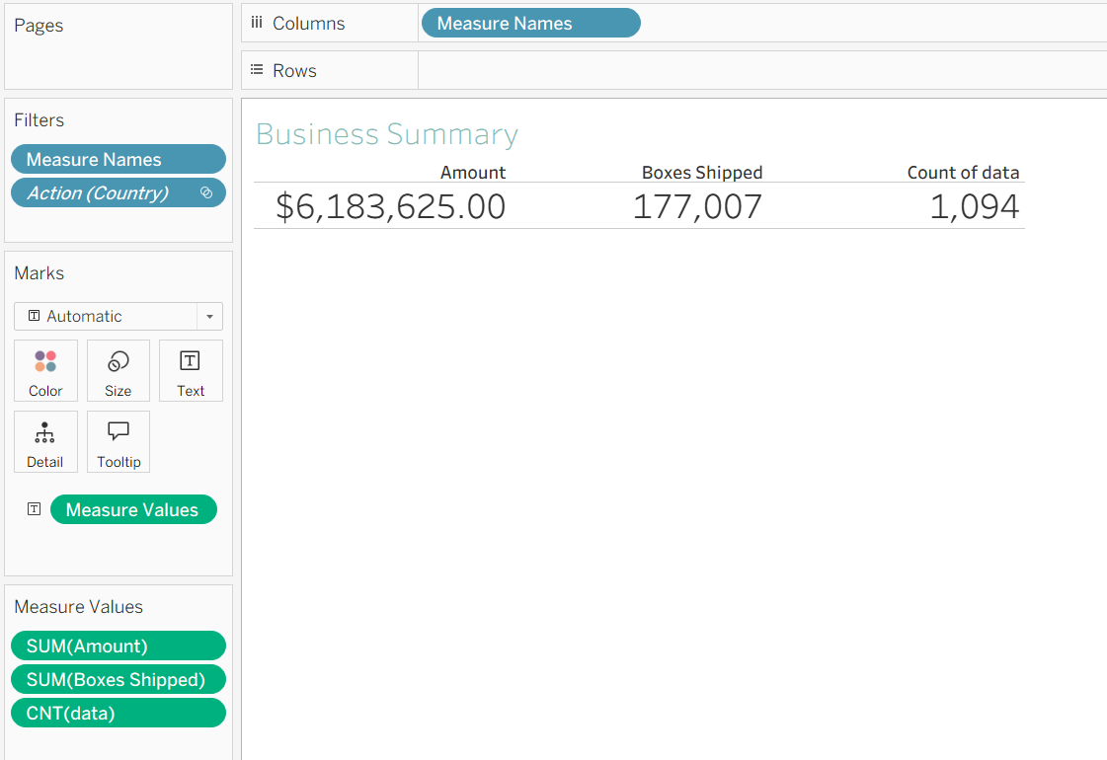
2. Sales by Country (Bar Chart)
This chart compares sales performance across different countries.
Explanation:
Each bar represents a country, and the height indicates total sales. This allows easy comparison of regional performance.
Insight:
Countries such as Australia, India, UK, and USA show relatively higher sales, indicating strong market presence.
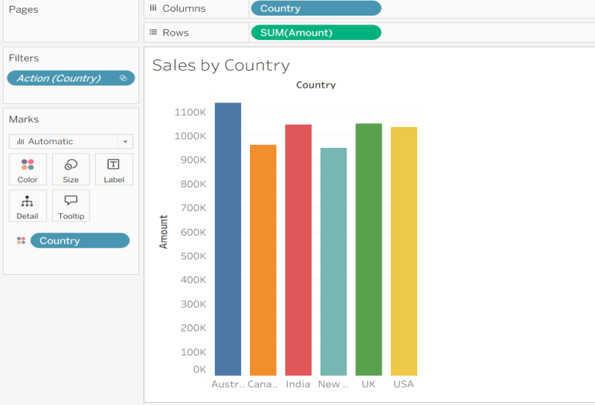
3. Sales by Top 10 (Stacked Bar Chart)
This visualization shows the top 10 salespersons and their contributions.
Explanation:
Each bar represents a salesperson, and different colors indicate contributions from different countries.
Insight:
- Helps identify top-performing employees
- Shows how different regions contribute to individual performance
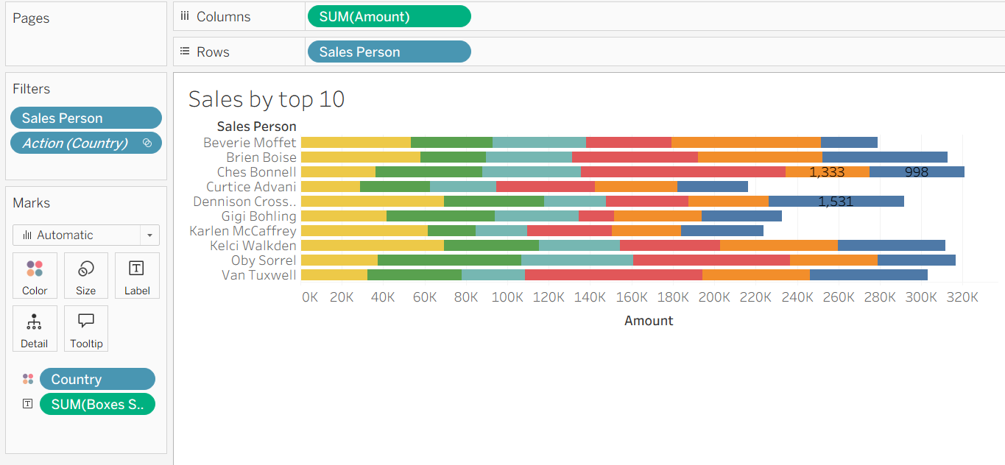
4. Distribution of Shipment Count (Pie Chart)
This chart shows how shipments are distributed.
Explanation:
Each slice represents a portion of total shipments.
Insight:
Shipment distribution appears relatively balanced, indicating efficient logistics management.
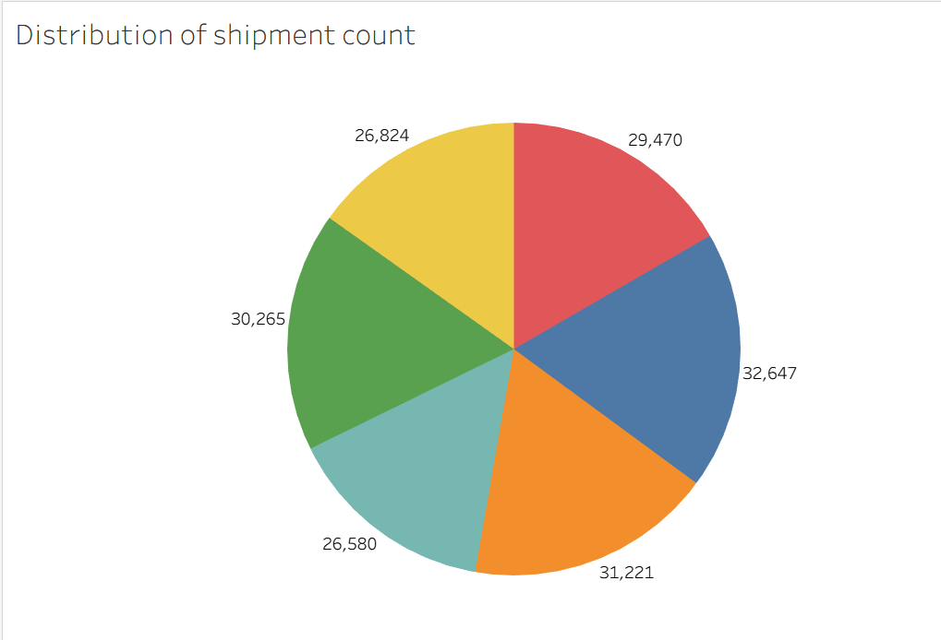
5. Product Share Across Countries (Heatmap Table)
This table shows product distribution across countries.
Explanation:
Color intensity represents product share.
Insight:
- Helps identify which products perform well in specific regions
- Useful for targeted marketing strategies
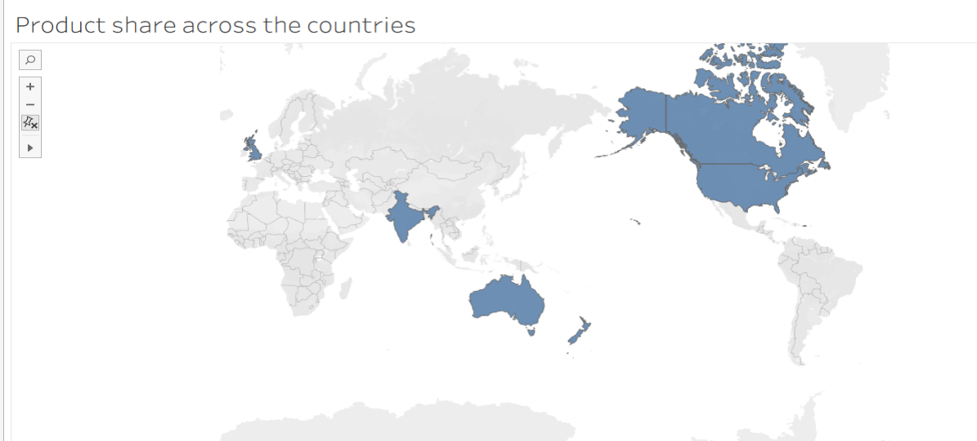
6. Dashboard Overview
The dashboard integrates all visualizations into one interface.
Explanation:
Users can view multiple aspects of data simultaneously, improving understanding and decision-making.
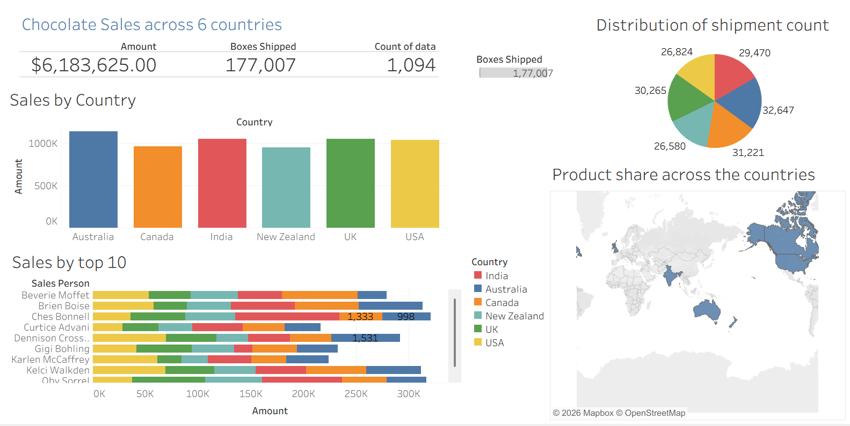
  - Types of Filters Used in Chocolate Dashboard
In the Chocolate Sales Dashboard, multiple filters are used to enhance data analysis and interactivity. These filters allow users to view specific subsets of data and perform focused analysis.
1. Category Filter (Product-Based Filter)
This filter is used to display data based on different types of chocolates such as Dark, Milk, and White chocolate.
Purpose:
- To analyze the performance of individual product categories
- To compare sales across different chocolate types
2. Region / Country Filter
This filter allows users to view sales data for specific geographical locations such as countries or regions.
Purpose:
- To understand regional performance
- To identify high-performing and low-performing markets
3. Date Filter (Time-Based Filter)
This filter is applied to analyze data based on time, such as year, quarter, or month.
Purpose:
- To study sales trends over time
- To identify seasonal variations in chocolate sales
4. Top N / Value Filter
This filter is used to display only the top-performing items, such as top-selling products or customers.
Purpose:
- To highlight key contributors to sales
- To focus on high-value data points
5. Action Filter (Interactive Filter)
This is an advanced filter that enables interactivity within the dashboard. When a user selects a specific element in one chart, all other visualizations update accordingly.
Purpose:
- To enable dynamic data exploration
- To improve user interaction and dashboard usability

  - Results & Insights
This section explains what you discovered after analyzing the dashboard.
- Results:
- The dashboard successfully presents overall business performance using KPIs such as total sales, shipments, and records.
- It provides a clear comparison between countries, showing variations in sales.
- It identifies the top 10 salespersons, highlighting their contribution to total sales.
- It visually represents shipment distribution, making logistics analysis easier.
- It shows product distribution across different countries, helping in understanding demand.
- Insights
Insights are the real meaning extracted from data:
- Some countries like Australia, India, UK, and USA contribute more to total sales → indicating strong markets.
- Sales performance is not equal across all regions, suggesting opportunities for improvement in lower-performing countries.
- A few salespersons contribute significantly higher sales, meaning performance is concentrated among top individuals.
- Shipment distribution is fairly balanced, indicating smooth logistics operations.
- Different products perform differently across countries → showing variation in customer preferences.
Simple line for viva:
“The dashboard helped in identifying patterns, comparing performance, and understanding business trends effectively.”

  - Conclusion
This project successfully demonstrates how Tableau can be used to analyze and visualize business data effectively. The dashboard provides a comprehensive overview of sales performance, helping users understand complex data through simple visual representations.
The use of multiple visualizations enhances clarity and supports better decision-making. This project highlights the importance of data visualization in modern business environments.
The conclusion summarizes the overall outcome of the project.
Explanation:
This project demonstrates how Tableau can be effectively used to analyze and visualize business data.
- The dashboard created provides a complete overview of business performance.
- It simplifies complex data into easy-to-understand visual formats.
- The use of charts helps in quick comparison and analysis.
- The project highlights the importance of data visualization in modern business environments.
Final understanding:
Data visualization tools like Tableau make it easier to:
- Interpret data
- Identify trends
- Support decision-making

  - Future Scope
This section explains how the project can be improved or extended in the future.
Explanation:
- The project can be enhanced by integrating real-time data sources, allowing live updates in the dashboard.
- Advanced analytics techniques such as machine learning and predictive modeling can be added to forecast future sales trends.
- The dashboard can be made more interactive by adding filters, drill-down features, and user controls.
- More datasets can be included to perform deeper and more comprehensive analysis.
- The project can be extended into a full business intelligence system for organizational use.
Simple line:
“Future improvements can make the dashboard more intelligent, interactive, and predictive.”
- Integration with real-time data sources
- Use of machine learning for predictive analysis
- Development of more advanced dashboards
- Implementation of automated reporting systems
- Expansion of dataset for deeper insights

Github –
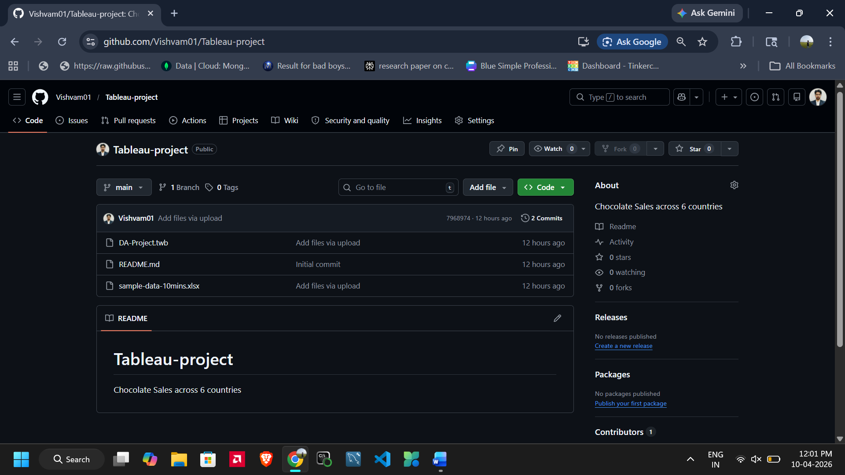

Github Link - https://github.com/Vishvam01/Tableau-project

